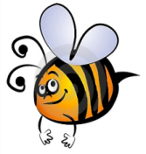
Name: #
Date:
Spelling Words for the Week of: ______________________________
List 6– Lesson 6: Consonants Digraphs ch, ph, sh, th, wh, tch
- Students are to review words at home and complete all assignments given.
- Spelling Pre-tests are given but NOT graded (they are a tool for students to focus on words they cannot spell). They MAY however, pass the pre-test and skip taking the test on Friday.
- Challenge words can only help your spelling test score. Each one you spell correctly will count towards any missed on the test . They will be randomly assigned.
- Highlight the spelling words you spelled incorrectly

- chestnut
- trophy
- shutter
- thorn
- pitch
- whale
- chipmunk
- phone
- toothbrush
- month
- patch
- whistle
- speech
- width
- watch

