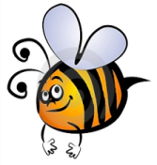
Name: #
Date:
Spelling Words for the Week of: ______________________________
List 4 - Lesson 4: Long Vowels o , u
- Students are to review words at home and complete all assignments given.
- Spelling Pre-tests are given but NOT graded (they are a tool for students to focus on words they cannot spell). They MAY however, pass the pre-test and skip taking the test on Friday.
- Challenge words can only help your spelling test score. Each one you spell correctly will count towards any missed on the test . They will be randomly assigned.
- Highlight the spelling words you spelled incorrectly

- bogus
- uniform
- coach
- truth
- bowl
- true
- antelope
- crew
- school
- group
- parachute
- bruise
- future
- ooze
- reduce

