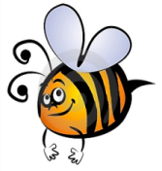
Name: #
Date:
Spelling Words for the Week of: ______________________________
List 3 – Lesson3: Long Vowels a, e, i
- Students are to review words at home and complete all assignments given.
- Spelling Pre-tests are given but NOT graded (they are a tool for students to focus on words they cannot spell). They MAY however, pass the pre-test and skip taking the test on Friday.
- Challenge words can only help your spelling test score. Each one you spell correctly will count towards any missed on the test . They will be randomly assigned.
- Highlight the spelling words you spelled incorrectly

- vacation
- reach
- describe
- sustain
- sleep
- flight
- break
- seize
- sky
- weigh
- field
- pioneer
- airplane
- study
- clay

