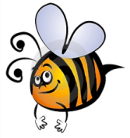
Name: #
Date:
Spelling Words for the Week of: _______________________________
List 2 – Lesson2: Short Vowels o, u
- Students are to review words at home and complete all assignments given.
- Spelling Pre-tests are given but NOT graded (they are a tool for students to focus on words they cannot spell). They MAY however, pass the pre-test and skip taking the test on Friday.
- Challenge words can only help your spelling test score. Each one you spell correctly will count towards any missed on the test . They will be randomly assigned.
- Highlight the spelling words you spelled incorrectly

- possible
- because
- straw
- broad
- bought
- swung
- problem
- taught
- paw
- sought
- jungle
- brought
- shuttle
- lobster
- umbrella

