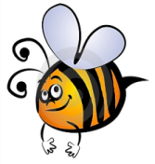
Name: #
Date:
Spelling Words for the Week of: ______________________________
- List 15 – Lesson 15: Irregular Plural Nouns
- Students are to review words at home and complete all assignments given.
- Spelling Pre-tests are given but NOT graded (they are a tool for students to focus on words they cannot spell). They MAY however, pass the pre-test and skip taking the test on Friday.
- Challenge words can only help your spelling test score. Each one you spell correctly will count towards any missed on the test . They will be randomly assigned.
- Highlight the spelling words you spelled incorrectly

- children
- deer
- dozen
- feet
- geese
- media
- men
- mice
- moose
- oxen
- sheep
- teeth
- traffic
- wheat
- women

