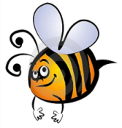
Name: #
Date:
Spelling Words for the Week of: ______________________________
List 14 – Lesson 14: Regular Plural Nouns
- Students are to review words at home and complete all assignments given.
- Spelling Pre-tests are given but NOT graded (they are a tool for students to focus on words they cannot spell). They MAY however, pass the pre-test and skip taking the test on Friday.
- Challenge words can only help your spelling test score. Each one you spell correctly will count towards any missed on the test . They will be randomly assigned.
- Highlight the spelling words you spelled incorrectly

- friends
- passes
- taxes
- buzzes
- benches
- bushes
- donkeys
- batteries
- patios
- echoes
- pictures
- valleys
- centuries
- radios
- tomatoes

