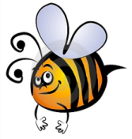
Name: #
Date:
Spelling Words for the Week of: ______________________________
- List 13 – Lesson 13: Special Spelling Patterns: Contractions
- Students are to review words at home and complete all assignments given.
- Spelling Pre-tests are given but NOT graded (they are a tool for students to focus on words they cannot spell). They MAY however, pass the pre-test and skip taking the test on Friday.
- Challenge words can only help your spelling test score. Each one you spell correctly will count towards any missed on the test . They will be randomly assigned.
- Highlight the spelling words you spelled incorrectly

- I’ll
- I’m
- she’s
- that's
- they’re
- what’s
- you’re
- he’d
- I’ve
- we've
- can’t
- don’t
- weren’t
- wouldn’t
- let’s

