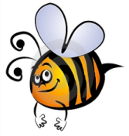
Name: #
Date:
Spelling Words for the Week of: ______________________________
List 11– Lesson 11: Special Spelling Patterns: ough, augh
- Students are to review words at home and complete all assignments given.
- Spelling Pre-tests are given but NOT graded (they are a tool for students to focus on words they cannot spell). They MAY however, pass the pre-test and skip taking the test on Friday.
- Challenge words can only help your spelling test score. Each one you spell correctly will count towards any missed on the test . They will be randomly assigned.
- Highlight the spelling words you spelled incorrectly

- aught
- bought
- caught
- brought
- daughter
- cough
- distraught
- fought
- fraught
- ought
- naught
- sought
- taught
- thought
- trough

