LINE
“A Mark or Stroke”
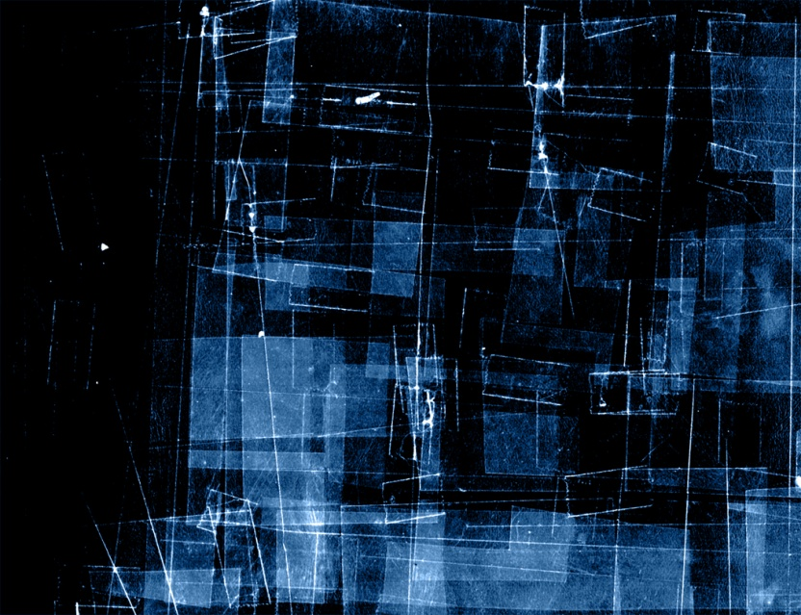
- Horizontal
- Vertical
- Diagonal
- Parallel
- Perpendicular
- Dotted
- Thick/Thin
- Zig zag/jagged
- Curvy/Curly

