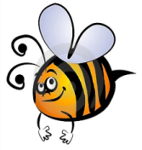
Name: #
Date:
Spelling Words for the Week of: __________________________
List 1 – Lesson1: Short Vowels a, e, i
- Students are to review words at home and complete all assignments given.
- Spelling Pre-tests are given but NOT graded (they are a tool for students to focus on words they cannot spell). They MAY however, pass the pre-test and skip taking the test on Friday.
- Challenge words can only help your spelling test score. Each one you spell correctly will count towards any missed on the test . They will be randomly assigned.
- Highlight the spelling words you spelled incorrectly

- perhaps
- necklace
- sweater
- inch
- happen
- empty
- invent
- athlete
- elephant
- until
- accident
- spell
- city
- adventure
- important

