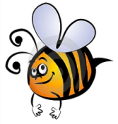
Name: #
Date:
Spelling Words for the Week of: ______________________________
- List 19 – Lesson 19: Rhyming Words
- Students are to review words at home and complete all assignments given.
- Spelling Pre-tests are given but NOT graded (they are a tool for students to focus on words they cannot spell). They MAY however, pass the pre-test and skip taking the test on Friday.
- Challenge words can only help your spelling test score. Each one you spell correctly will count towards any missed on the test . They will be randomly assigned.
- Highlight the spelling words you spelled incorrectly

- apple
- dapple
- center
- enter
- prince
- mince
- clock
- stock
- bake
- cake
- city
- ditty
- flute
- fruit
- hoot

