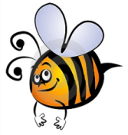
Name: #
Date:
Spelling Words for the Week of: ______________________________
List 12 – Lesson 12: Special Spelling Patterns: Compound Words
- Students are to review words at home and complete all assignments given.
- Spelling Pre-tests are given but NOT graded (they are a tool for students to focus on words they cannot spell). They MAY however, pass the pre-test and skip taking the test on Friday.
- Challenge words can only help your spelling test score. Each one you spell correctly will count towards any missed on the test . They will be randomly assigned.
- Highlight the spelling words you spelled incorrectly

- applesauce
- baseball
- blueprint
- bookshelf
- cupcake
- daylight
- drawbridge
- grandparents
- haircut
- horseback
- housework
- mailbox
- sunset
- textbook
- volleyball

